Department Source: City Manager and Police Departments
To: City Council
From: City Manager & Staff
Council Meeting Date: November 6, 2017
Re: Vehicle Stops and Listening Tour Summary

Executive Summary

The racial disparities in the Columbia Police Department’s vehicle stops data has been the source of concern and alarm for many members in the community. In order to better understand the racial disparities in vehicle stops, City staff have studied and reviewed the data. The City Manager, Police Chief, CPD command staff, and other City staff also went on a listening tour and participated in the NAACP’s Community Engagement on Policing, Equity and Civility to get public input on the racial disparities and learn about individuals’ personal experiences with vehicle stops. The purpose of this report is to provide information on the Missouri Attorney General’s Vehicle Stops Report and the vehicle stops data for the Columbia Police Department; discuss the listening tour and the overarching themes that were identified from the meetings; discuss the NAACP’s Community Engagement on Policing, Equity and Civility and address the five recommendations that have initially resulted from that process; identify measures that the City has implemented to address racial disparities in traffic stops and other equity issues; and identify additional potential measures that the City could undertake to address racial disparities and other equity issues.
Discussion

Missouri Attorney General’s Vehicle Stops Report

State law requires all peace officers to report specific information about every vehicle stop that is made in Missouri. Examples of the information that is collected includes the race of the driver, reason for the stop, outcome of the stop, whether or not a search was conducted, whether or not contraband was found during a search, and whether or not an arrest occurred as a result of a stop. Each year law enforcement agencies submit their data on vehicle stops to the Missouri Attorney General’s Office and the data is published in the Vehicle Stops Report.

In addition to collecting and publishing the data, the Vehicle Stops Report analyzes the state’s aggregate vehicle stops data by race/ ethnicity according to four summary indicators:
- Disparity Index: “The ‘disparity index’ compares the percentage of traffic stops involving members of a certain group to the percentage of driving-age individuals who are members of that group, as measured by the 2010 Census.” This indicator is calculated using the following formula: (proportion of stops / proportion of population). A value of 1 represents no disparity; values greater than 1 indicate over-representation, values less than 1 indicate under-representation.
- Search Rate: “The ‘search rate’ reflects the percentage of stopped drivers whose person or vehicles were searched as part of the stop. Searches include searches of drivers or property in the vehicle.” This indicator is calculated using the following formula: (searches / stops) X 100.
- Contraband Hit Rate: “The ‘contraband hit rate’ reflects the percentage of searches in which contraband is found.” This indicator is calculated using the following formula: (searches with contraband found / total searches) X 100.
- Arrest Rate: “The ‘arrest rate’ reflects the percentage of stopped drivers who are arrested during the stop.” This indicator is calculated using the following formula: (arrests / stops) X 100.

The Vehicle Stops Report publishes the vehicle stops data and calculates the summary indicators for every law enforcement agency that submits data. The data for the Columbia Police Department displays racial disparities with vehicle stops. Two areas where the racial disparities are most prevalent are the disparity indexes and search/ contraband hit rates for the white and black populations.

The disparity index is the first summary indicator that shows racial disparities. In 2016, the Columbia Police Department conducted 11,819 vehicle stops. Of those stops, 3,691 occurred with black drivers and 7,416 occurred with white drivers. The disparity index for black drivers was 3.13; black drivers accounted for 31.23 percent of all vehicle stops and made up 9.96 percent of the local population. By comparison, the disparity index for white drivers was 0.79; white drivers accounted for 62.75 percent of all vehicle stops and made up 79.71 percent of the local population. As it was previously stated, “a value of 1 represents no disparity; values greater than 1 indicate over-representation, values less than 1 indicate under-representation.” When comparing the proportion of vehicle stops to the proportion of the population it can be seen that black drivers were over-represented in the vehicle stops. When comparing black drivers and white drivers, it can also be seen that black drivers have a disparity index nearly four times greater than the disparity index for white drivers.

The search rates and corresponding contraband hit rates is another area where racial disparities are present. In 2016, black drivers experienced a search rate of 16.58 and a contraband hit rate of 39.38. By comparison, white drivers experienced a search rate of 9.22 and a contraband hit rate of 40.20. As it can be seen from the rates, black drivers were searched at higher rates compared to white drivers, but the searches on black drivers yielded contraband at a slightly lower rate compared to white drivers.

There are improvements that can be made to the Vehicle Stops Report. One issue with the report is that the data lacks definitions and guidelines which leads to inconsistencies in how it is collected and reported. For example, there are four “reasons” for a vehicle stop listed on the report: moving, equipment, license, and investigative. When an officer conducts a stop he/she selects the reason for the vehicle stop. Because there are not definitions or guidelines for reporting the data, two officers may experience the same situation and report it differently.

Take the following scenario as an example: An officer conducts a vehicle stop because a driver failed to use their turn signal when switching driving lanes. When discussing the reason for the stop with the driver the officer discovers that the turn signal equipment on the driver’s vehicle is defective. When recording this event the officer must use his/ her discretion to decide if the reason for the vehicle stop is moving (failing to use a turn signal while switching lanes) or equipment (the turn signal equipment was defective). As it can be seen from this example, and there are many others similar to this one, without clear definitions officers may interpret the same situations differently. Failing to report data correctly and in a consistent manner leads to inaccurate data. Inaccurate data can lead to measures being implemented that are not needed.

How investigative stops are interpreted and reported is also an area where definitions and guidelines would be helpful. As CPD continues to use saturation patrols and officers are deployed to areas in an attempt to identify the people committing violent crimes, one would expect the number of investigative stops to be greater than what has been reported. Specifically, in 2016 there was a total of 350 vehicle stops for investigative reasons. Because this number is so low and such a small percentage of total vehicle stops, it is assumed that officers are performing vehicle stops for other legitimate reasons (i.e. equipment stops, license stops, etc.) and then using that vehicle stop for investigative purposes. If this is the case, then law enforcement agencies should give guidelines and make a determination on how these types of stops should be categorized. If the intent of the stop is for investigative purposes, then the officer should make note of that fact in how the data is reported.

Another identified issue with the data is that total stop outcomes do not equal total vehicle stops. In 2016 there were 11,819 vehicle stops and there were only 11,501 stop outcomes (1,299 citations, 10,172 warnings, and 30 no action) listed on the Vehicle Stops Report for CPD. There are 318 traffic stops where an outcome is not given. This is a flaw with the report data because every vehicle stop should have a corresponding outcome.

The Vehicle Stops Report data also does not take into account outside factors or viable explanations for the racial disparities. Don Love, chairman of Empower Missouri’s Human Rights Task Force, made this point in the following statement: “Keep in mind that high disproportions do not prove bias. There can be numerous legitimate reasons for a disproportion. If officers and their agency cannot explain a disproportion by legitimate factors, then no officer is proven to have been intentionally discriminating against individuals based on race, but a strong presumption is created that some form of bias is involved.”

One example of how the Vehicle Stops Report fails to take into account the impact of other legitimate factors on racial disparities is the impact of poverty. In Columbia, black people experience significantly higher levels of unemployment and poverty compared to white people. According to most recent five-year estimate data, black people experienced family poverty rates of 28.9 percent and unemployment rates of 11.9 percent, whereas white people experienced family poverty rates of 6.9 percent and unemployment rates of 3.7 percent.

This is relevant to the discussion of vehicle stops because “equipment” and “license” stops are impacted by a person’s economic means. A person in poverty may not have the financial ability to pay for vehicle repairs (i.e. broken taillight, nonfunctioning turn signal, etc.) or license their vehicle (i.e. cannot afford to pay vehicle sales tax or other associated costs, do not have the funds to get their vehicle in proper working order to pass a vehicle inspection, etc.). Also, it is perceived that people of less economic means are more likely to drive older cars in need of equipment repairs. Therefore, it can be concluded that people in poverty are at a greater risk of being the subject of a vehicle stop for equipment and license reasons. This point is especially important considering the fact that equipment and license stops accounted for 62.88 percent of all vehicle stops in Columbia in 2016. Taking this information into consideration, it can be seen how factors not accounted for in the vehicle stops data can impact the racial disparities. (While on the subject of poverty it is also important to point out that CPD issued warnings on vehicle stops 88.44 percent of the time in 2016, which do not have monetary fines like citations.)

Another factor to mention which has impacted the racial disparities is the fact that as the total number of stops has decreased the differences in the racial disparities have increased. In 2010, CPD performed 23,954 total vehicle stops (white drivers accounted for 18,098 stops and black drivers accounted for 4,907 stops). This is the greatest number of stops performed in a year for CPD. During the same year, white drivers had a disparity index of 0.93 and black drivers had a disparity index of 2.02. This accounted for one of the lowest racial disparities in the disparity index. By contrast, in 2016, CPD performed 11,819 total vehicle stops (white drivers accounted for 7,416 stops and black drivers accounted for 3,691 stops), which is one of the lowest number of total stops performed in a year for CPD. During the same year, white drivers had a disparity index of 0.79 and black drivers had a disparity index of 3.13. This resulted in the greatest racial disparity in the disparity index. This data shows that the number of total vehicle stops has an impact on the differences in the racial disparities. (Please refer to figures 1 and 2 for a graphical representation of the data.)

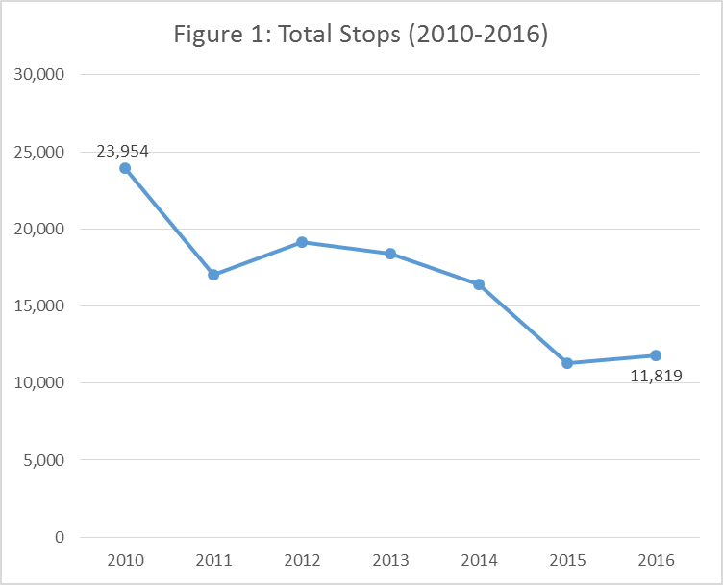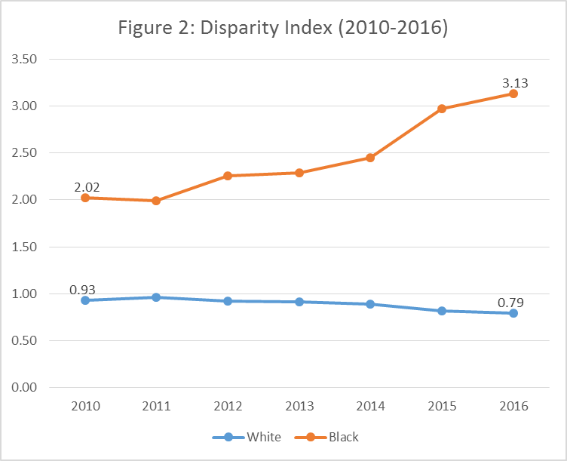

There are several reasons why the number of vehicle stops have decreased. One explanation for the drastic decrease in vehicle stops in recent years was the disbandment of the traffic unit. The traffic unit’s purpose was to enforce traffic laws on major roadways and intersections, in high accident areas, and in school zones. This resulted in officers in the traffic unit writing a high number of citations for moving violations. With the disbandment of the traffic unit, the black population was disproportionately impacted because the percentage decrease in vehicle stops for black drivers was much lower compared to the percentage decrease in vehicle stops for white drivers based on the geographic area patrolled.

Listening Tour

In the executive summary to the Vehicle Stops Report it states, “I hope this data will help us toward a constructive conversation about what we must do together to better achieve—and protect—the rule of law in our state.” The purpose of the listening tour was to begin that conversation by having an open and honest dialogue with individuals and community groups. The listening tour sought to do this by giving an opportunity to share information and discuss experiences regarding racial profiling, specifically during vehicle stops, and the data from Vehicle Stops Report. The listening tour consisted of meetings of City staff (City Manager Mike Matthes, Police Chief Ken Burton and CPD command staff, and others) and local community groups and community members. The listening tour occurred on the following dates with the following organizations:
- September 9, 2016: NAACP (planning meeting for community engagement meetings)
- October 11, 2016: Minority Men’s Network
- October 25, 2016: Race Matters, Friends
- October 26, 2016: Empower Missouri
- January 30, 2017: Public Town Hall Meeting
- March 1, 2017: NAACP (planning meeting for community engagement meetings)
- April 25, 2017: NAACP (listening tour with Deputy Chief Schlude)
- May 22, 2017: NAACP (listening tour with Chief Burton)

At each of the meetings, notes were captured by City staff. After the meetings had been completed, City staff used techniques outlined by Ryan and Bernard to categorize the comments into themes. First, the comments were reviewed and marked up (a method the authors referred to as “pawing”) in order to identify key phrases and “topics that occur and reoccur.” The comments within each of the reoccurring topics were then “cut and sorted” to identify overarching themes from the listening tour comments. As a result of this process the following themes were identified:
- Communication methods: There are many different communication methods at the City’s disposal, use as many of them as possible to reach the greatest number of people.
- Verbal and nonverbal communication: What is said and how it is said is important.
- Personal, anecdotal stories: Place a value on others’ personal, anecdotal stories.
- Perception: A person’s perception is their reality.
- Perspective: The individual’s perspective (socioeconomic status, race, biases, experiences, etc.) impacts how they view things.
- Data: Analyze the data and focus on solutions.
- Fear: There is fear throughout the community.
- Searches/ consent cards: There are a lot of questions regarding searches and the consent search policy.
- Officer recruitment: There needs to be an effort to recruit more minorities to the police force.
- Training: The training that CPD officers receive should include issues outside of traditional policing techniques (i.e. mental health, multicultural, verbal de-escalation, etc.) and incorporate local organizations and local experts to serve as trainers.
- Additional meetings: The NAACP discussed hosting a large meeting with multiple groups to review information and come up with potential solutions.
- Miscellaneous: There were comments, questions, and recommendations that did not fit into any of the previously mentioned categories and those comments were categorized within this miscellaneous category.
(The notes for each of the listening tour meetings can be found in the appendix section of this report.)

NAACP Community Engagement on Policing, Equity and Civility

In addition to the listening tour, members of the City Council and City staff participated in the NAACP’s Community Engagement on Policing, Equity and Civility. The meetings occurred on August 22, 2017 and September 26, 2017. Hundreds of people attended the meetings “to hold honest dialogues, form partnerships, and create new opportunities in Columbia.” Specific topics and breakout groups included:
- Civility and accountability
- Community engagement
- Community policing and racial profiling
- Mental health and community policing
- Equity in employment and minority entrepreneurship

At the August 22nd meeting, issues were discussed and potential solutions were brainstormed for each of the topics. At the September 26th meeting, solutions for each topic were prioritized and each breakout group identified one specific recommendation to work on. The following is the recommendation from each breakout group and a corresponding initial commitment from the City on how the recommendation will be addressed:

Civility and Accountability
- Recommendation: Accountability and transparency for law enforcement.
- City Commitment: The City has taken several measures to address accountability with the police department. Some examples include the Citizen Police Review Board, body-worn cameras for all officers, and the issuance of a directive to have all racial profiling complaints investigated by the Internal Affairs Unit. CPD is currently going through the accreditation process with the Commission on Accreditation for Law Enforcement Agencies (CALEA). With accountability as one of the primary cornerstones of the CALEA standards, going through this process will help to ensure that CPD is following best practices on law enforcement accountability.

Community Engagement
- Recommendation: Get together to have fun.
- City Commitment: This was identified as something that the community would take the lead on by planning and hosting events for all members of the community. The City is committed to ensure that the events are attended by members of the police and fire departments, as well as other City administration and staff, in order to help build and strengthen relationships between the community and the City government.

Community Policing and Racial Profiling
- Recommendation: Require cultural diversity training for officers (balance of nationally recognized curriculum and utilize community members to facilitate trainings).
- City Commitment: CPD officers are required to participate in trainings on cultural diversity. The City also offers training to all City staff and members of boards and commissions on the National Conference for Community and Justice’s (NCCJ) curriculum. This training discusses many topics including race, gender, LGBTQ, abilities, and class. The City is committed to continuing to identify additional training opportunities on cultural diversity. The City will explore the idea of working with interested members of the community to serve as facilitators for selected training topics. It is important to mention that cultural diversity trainings taught by members of the community would need to be Peace Officer Standards and Training (POST) certified before being added to the training curriculum.

Mental Health and Community Policing
- Recommendation: Create a task force made up of law enforcement officers, mental health experts, city officials, and people with mental health diagnoses.
- City Commitment: Upon the creation of a task force, the City is committed to providing personnel from relevant City departments including the Police Department and Public Health and Human Services Department to serve on the task force.

Equity in Employment and Minority Entrepreneurship
- Recommendation: Human resources hiring practices not using name.
- City Commitment: This recommendation would complement the “Ban the Box” legislation that was passed by City Council on December 1, 2014. The City is committed to exploring how this could be implemented into City hiring practices and will submit a report to council on this topic.

The NAACP’s community engagement process has provided additional insight and community input on the racial disparities in the vehicle stops data, as well as helped to identify potential solutions regarding other racial inequities in our community. The NAACP community engagement process is an ongoing effort and the City will continue to be an active participant in that process. (The notes for the breakout sessions from the August 22nd and September 26th meetings can be found in the appendix section of this report.)

Addressing Racial Disparities and Other Identified Issues: What has been done?

Prior to the publication of the Vehicle Stops Report and the listening tour, the City had already taken measures to address racial profiling complaints and other reported officer misconduct. Two examples include the Citizen’s Police Review Board and body cameras for all officers.

Citizen’s Police Review Board. In 2009, the City of Columbia established the Citizens Police Review Board (CPRB). The CPRB provides an external and independent process for review of actual or perceived misconduct thereby increasing police accountability to the community and community trust in the police. The CPRB reviews appeals from the police chief's decisions on alleged police misconduct; hosts public meetings and educational programs for Columbia residents and police officers; reviews and makes recommendations on police policies, procedures and training; and prepares and submits annual reports that analyze citizen and police complaints to the City Council. (The CPRB Annual Reports from 2015 and 2016 can be found in the appendix section of this report.)

Body-Worn Cameras. In 2014, CPD purchased body-worn cameras for all officers, becoming the first law enforcement agency in the state to take that step. Any time that an officer has an interaction with the public, which includes vehicle stops, the officer must record the interaction. The body cameras can then be reviewed to investigate misconduct, thereby increasing police accountability to the community.

As a result of an internal review of the Vehicle Stops Report and public input from the listening tour and NAACP community engagement process, measures have been taken to address racial disparities in vehicle stops and other identified equity issues.

Racial Profiling Complaint Procedures. Previously, when a racial profiling complaint was made against an officer, the complaint could have been investigated by the officer’s supervisor or the Internal Affairs Unit. In order to ensure that all racial profiling complaints are investigated in a similar manner and given the necessary amount of time and attention, Chief Burton issued a directive to have all racial profiling complaints investigated by the Internal Affairs Unit.

Consent to Search Forms. In response to the racial disparities in the search rates, CPD implemented a practice of having officers obtain written consent prior to consent searches. The Consent to Search form instructs a driver of their constitutional rights with regard to consent searches and makes the driver aware that consent can be withdrawn at any time. Due to the Consent to Search forms being a new process, CPD will continue to review the process and make improvements to the forms. (A copy of the Consent to Search form can be found in the appendix section of this report.)

Educational Requirements for Hiring. As the result of a discussion on officer recruitment with the NAACP during a listening tour meeting, CPD changed the educational eligibility requirements to become a police officer. The educational requirement was changed from requiring an individual to have 60 college credit hours to a high school diploma. The goal of this measure is to attract a more diverse applicant pool including experienced officers from other cities who do not have college credit.

Training. The subject of training and the types of training that officers receive was an important topic for many community members. Currently, CPD officers receive many trainings that address a diverse range of topics. Examples of those trainings include racial profiling training; officer well-being training, including mental health awareness; Fair and Impartial Policing Practices, which includes implicit bias recognition; handling persons with mental health and cognitive impairment issues; and tactical training which includes de-escalation techniques, crisis management, critical thinking, and social intelligence. In an effort to educate the public about the implicit bias training that CPD provides to its officers, Sgt. Hestir facilitated the Fair and Impartial Policing Training for the public on November 5, 2016. (The CPD training requirements can be found in the appendix section of this report.)

The City has also contracted with the National Conference for Community and Justice (NCCJ) to have employees certified in their curriculum. The curriculum includes topics on race, gender, LGBTQ, abilities, and class. The class is open to all City employees and members of City boards and commissions. The City has 5 employees certified to train the curriculum and 2 additional employees are in the process of completing the certification. The trainers include employees from all levels of the organization from a Deputy City Manager to frontline workers in different departments.

President’s Task Force on 21st Century Policing. CPD has committed to implementing and practicing the pillars outlined in the President’s Task Force on 21st Century Policing. In December of 2015, a presentation was given to councilmembers as part of the pre-council meeting. The presentation outlined actions that CPD had already taken or were committed to taking with regards to the 6 pillars outlined by the President’s Task Force on 21st Century Policing. (A copy of President’s Task Force on 21st Century Policing Final Report and Columbia Police Department’s Report on 21st Century Policing can be found in the appendix section of this report.)

White House Police Data Initiative/ Vehicle Stops Data transparency. In October of 2016, CPD joined the White House Police Data Initiative. CPD’s commitment to the initiative “supports leveraging data to increase transparency, accountability, and build trust with the citizens of Columbia.” As a result of joining this initiative, CPD has released open data sets on the vehicle stops data. The data sets provide citizens the opportunity to download, sort, search, filter, or analyze the data for their own needs. All data sets are available on CPD's website, as well as the national Public Safety Open Data Portal at www.publicsafetydataportal.org.

Records Management System. CPD has purchased a new records management system. Once the system is implemented, officers will be required to comply with more rigorous reporting standards in order to help ensure previously identified issues with the data are addressed. For example, CPD can make it a requirement for every vehicle stop to have a corresponding stop outcome. It is important to mention that once the records management system is implemented, all law enforcement agencies in Columbia will be using the same system and this will help to improve record sharing across jurisdictions.

Adopt a Policy on Bias-Free Policing. Chief Burton has committed to working with Empower Missouri and other interested stakeholders to adopt a policy on bias-free policing in line with the philosophy of Lorie Fridell, an expert in this area. The policy “boils down to saying officers must act on facts about the individual, which is the essence of good policing. In the context of concerns about the possibility of officers being influenced by our history of racial subjugation, this means officers learn to ignore stereotypes by disciplining themselves to look for facts clearly independent of race and acting only if they find probable cause or, in cases in which they are permitted more discretion, compelling indications of criminal behavior.”

Addressing Racial Disparities and Other Identified Issues: Other Considerations?

In addition to measures that have already been taken and the five recommendations from the NAACP community engagement process, the following ideas are other options to consider.

Define Key Terms and Establish Guidelines Relating to Vehicle Stops Data. The data in the Vehicle Stops Report has terms that are not defined by state law or local ordinance. This requires officers to use their discretion which leads to inconsistencies in the collection and reporting of data. Examples include defining the four “reasons” for stops; issuing guidelines on investigative stops and when they should be reported as compared to other types of stops; issuing guidelines on how to record a driver’s race/ ethnicity (use what is listed on the driver’s license and not the officer’s perception); and guidelines on when vehicle stops data must be recorded and submitted.

Analysis/ Research Report Conducted by (or with) an Outside Organization. In an effort to gain an independent perspective, CPD could contract with an outside person or organization to review and analyze the City’s vehicle stops data. The report could also provide recommendations on policy changes and ways to lower racial disparities. Other law enforcement agencies in the United States have taken this approach to discuss the vehicle stops data for their communities. (Examples of law enforcement agencies working with outside organizations to review and analyze vehicle stops data include the Greensboro Police Department and Durham Police Department. The reports for these agencies can be found in the appendix section of this report.)

Annual in-house report on Vehicle Stops Report. It is important for the City do a better job of communicating with the community about the vehicle stops data. To accomplish this CPD could conduct a review and issue an annual report outlining their findings and opportunities for improvement. This report allows the department to discuss outside factors and viable explanations for why racial disparities might exist in the vehicle stops data.

Reconstitute a Traffic Unit. The data shows that the number of total vehicle stops has had an impact on racial disparities. Specifically, when the number of vehicle stops was the highest the racial disparities were lower compared to other years. One effort that can be taken to increase the number of vehicle stops is to reconstitute a traffic unit. The traffic unit would enforce traffic laws on major roadways and intersections, in high accident areas, and in school zones.

This idea also falls in line with an initiative in the Vision Zero Action Plan which called for reconstituting a traffic unit for police traffic safety enforcement. Vision Zero data demonstrates that peak traffic accidents occur Monday through Friday, between 3:00 pm and 6:00 pm. These hours should be the focus of any increased enforcement.

Conclusion

Many of the measures outlined in this report have been implemented within the past year or will be implemented in the near future. The measures have not been in place long enough to have their desired effect and it is anticipated that there will not be a significant change in the racial disparities on the 2017 Vehicle Stops Report. This is important to point out because despite the anticipated data, progress has been made. As a result of this process, the City government and community have come together and started an honest dialogue, relationships have been established and strengthened, and many measures have been implemented.
Fiscal Impact

Short-Term Impact: The measures outlined in this report that have already been implemented do not have a fiscal impact beyond what has already been budgeted. If council chooses to implement other measures then there could be a fiscal impact and additional funds would be required.
Long-Term Impact: The measures outlined in this report that have already been implemented do not have a fiscal impact beyond what has already been budgeted. If council chooses to implement other measures then there could be a fiscal impact and additional funds would be required.

Strategic & Comprehensive Plan Impacts

Strategic Plan Impacts:
Primary Impact: Public Safety, Secondary Impact: Social Equity, Tertiary Impact: Not Applicable

Comprehensive Plan Impacts:
Primary Impact: Not Applicable, Secondary Impact: Not applicable, Tertiary Impact: Not Applicable

Legislative History

None.
Suggested Council Action

This report is for informational purposes.

Missouri Attorney General. “Vehicle Stops Report.” Executive Summary. (https://ago.mo.gov/home/vehicle-stops-report).
Missouri Attorney General. “Vehicle Stops Report.” Executive Summary. (https://ago.mo.gov/home/vehicle-stops-report).
Ibid.
Ibid
Ibid.
Don Love. “Empower Missouri CPD Data Workshop.” E-mail message from author, September 1, 2017.
United States Census Bureau. American Community Survey. Tables: S2301 (Employment Status) and S1702 (Poverty Status in Past 12 Months of Families). (https://factfinder.census.gov/faces/nav/jsf/pages/index.xhtml).
Missouri Attorney General. “Vehicle Stops Report.” Executive Summary. (https://ago.mo.gov/home/vehicle-stops-report).
Gery W. Ryan and H. Russell Bernard. “Techniques to Identify Themes.” Field Methods. Vol. 15, No. 1, February 2003, pp. 85-109.
City of Columbia, Missouri website. Law and Prosecutor’s Office. “Ban the Box” Frequently Asked Questions. https://www.como.gov/law/human-rights/ban-the-box/ban-the-box-faq/?doing_wp_cron=1507218769.8422369956970214843750.
City of Columbia, Missouri website. Boards, Commissions, Committees and Task Forces. Citizens Police Review Board. https://www.como.gov/Council/Commissions/description.php?bcid=14
Columbia Police Department Press Release. “CPD joining the White House-led Police Data Initiative.” October 13, 2016. https://www.como.gov/CMS/pressreleases/view.php?id=4429
Don Love. “Bias-free/Racial Profiling Policy Reform.” E-mail message from author, September 19, 2017.

