TO: CATSO Coordinating Committee

FROM: CATSO Staff

SUBJECT: Item 7 – GoCOMO FAST Act Transit Asset Management Targets

DATE: November 13, 2017

The federal Map-21 legislation established, and the Fast Act continues, a performance-based approach to transportation projects. Seven national performance goals were established for the Federal-Aid Highway Program. From these seven goals, fifteen performance measures were developed for states, MPOs, and transit agencies, which are required to set goals and monitor progress. Transit Asset Management is the first performance measure for which targets must be set. Additional targets will be developed by CATSO as required.

Accordingly, GoCOMO was required to develop an asset management plan for their public transportation assets, including vehicles, facilities, equipment and other infrastructure by January 1, 2017. Now that CATSO has been made aware of the GoCOMO targets, which mirror the transit asset management targets set by MoDOT, it must adopt and affirm the GoCOMO targets within 180 days.

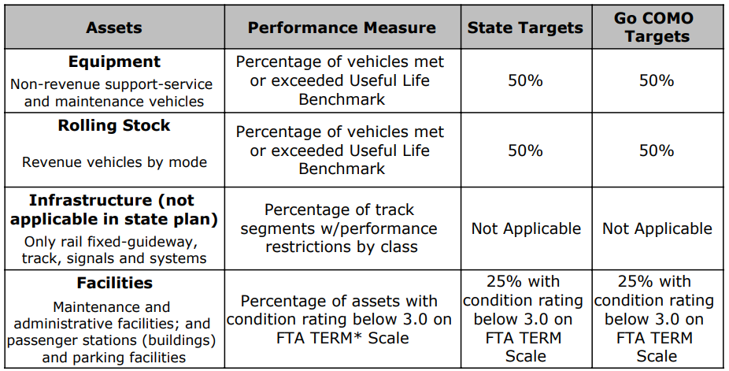
*TERM is a Federal Transit Administration Transit Economic Requirements Model that helps transit agencies assess their state of good repair backlog, level of annual investment to attain state of good repair, impact of variations in funding and investment priorities.

Technical Committee Review and Action

At their November 1, 2017 meeting, the CATSO Technical Committee reviewed the GoCOMO transit asset management targets. After a staff overview and discussion, the
Item 7 – November 13, 2017 CATSO Coordinating – Proposed Revision of CATSO By-Laws
Page 2

committee unanimously passed a motion to forward the transit asset management targets to the CATSO Coordinating Committee for review and approval at the special November 13, 2017 meeting.

Suggested Coordinating Committee Action

After review and discussion, formally adopt the GoCOMO FAST Act transit asset management targets.

