Submitted by: Environment and Energy Commission
Rental Energy Efficiency Report
February 2017

Table of Contents
Proposal from Environment and Energy Commission (EEC) 2
Introduction 2
Background on Current Efforts 3
Vision & Strategic Plan Impacts 5
Appendix A - Comments from the November 29, 2016 Public Meeting 6
Appendix B - Rental Property Scoring 9
Programs 11
Home Performance with Energy Star 11
Home Energy Score 11
Efficiency Score 11
Appendix C - List of Benefits from the Proposal 12
Benefits to Renters 12
Benefits Community 12
Economy 12
Social Equity 12
Infrastructure 12
Benefits the Environment 12
The Vision for Columbia's Future 12
Appendix D – Comments from Strategic Plan Neighborhood surveys related to home energy 13

Proposal from Environment and Energy Commission (EEC)

This falls under ARTICLE V. - RENTAL UNIT CONSERVATION LAW
Ordinance 22-186 -Application for (rental) certificate:

(f) Beginning January 1, 2018 the application for certificate of compliance for all rental units that qualify for the Home Performance with Energy Star shall be accompanied by a copy of the property’s Home Energy Score OR an Efficiency Score which has been issued within the last 10 years. Home Energy Score must be 7 or higher or Efficiency score must be 70% or higher. This requirement is waived for properties that have completed a Home Performance with Energy Star assessment and completed any of the recommendations before January 1, 2018.

Introduction

The EEC has been working on energy efficiency in rental housing since 2010. Members of the City Council have been concerned with the cost of energy for lower income citizens of Columbia since at least the mid-1980s.

Columbia has 27,398 rental housing units. 10,878 of these are single-family, duplexes, or townhouses: this proposal potentially affects these housing types.

The gross cost of occupancy (rent and utilities) for more than half (50.5%) of rented homes is more than 35% of household income. Further, 24.9% of Columbia’s population is living below the Federal poverty level. In FY 2016, utilities were disconnected over 9,000 times last year for non-payment.

Reducing the cost of utilities requires, in most cases, efficiency improvements. The two largest energy efficiency improvements are more insulation and reduced air infiltration; this proposal is designed to achieve these improvements.

The Home Performance with Energy Star Program has been available in Columbia since 2008. Columbia has experienced substantial voluntary participation. However, there has not been a high level of participation in the rental property segment. Rental property owners have no economic motivation to make improvements that benefit tenants who pay the utility costs, and renters have no economic motivation to make improvements to buildings they don’t own. This is commonly called the property-owner/renter divide. This is a problem the City Council has been aware of for decades. The proposed ordinance addresses this problem.

Background on Current Efforts

At the City Council meeting on April 4, 2016 The Council discussed EEC’s proposal for requiring minimal levels of energy efficiency in rental housing. The Council requested that we meet with constituents. On November 29, 2016, EEC held such a meeting with over 80 people attending. See Appendix A for details.

Several concerns surfaced during the meeting:
- Accurate information on energy needs was strongly desired by both renters and property owners.
The Home Energy Score and the Efficiency Score provide a cost estimate based upon characteristics of the house rather than occupant habits (Appendix B). One property-owner offered an example of “an inefficient tenant ruining the reputation of a property because of using excess energy.” It also addresses the problem of obtaining data from Ameren Missouri on the cost of heating with natural gas, which is typical in single-family housing, because though total energy is calculated, heating cost is calculated separately.
- There was a strong interest in helping renters reduce energy costs by providing information that would cause them to change their energy behavior.
EEC has discussed this problem with the City’s energy educator who is working to develop information for tenants which does not emphasize asking the property-owner to fix the problem.
- There were suggestions that we apply any regulation to all residential property.
EEC believes that there are possibilities for regulating rental property other than single-family houses. We do note that the single-family houses are the only property for which an objective measure of energy use is currently available. We also note that this type of housing has higher energy needs than residential property that shares walls, floor and ceiling with other residential units since the major energy use is temperature control in any housing. EEC will develop recommendations for other types of property. Single-family rental housing encompasses many of the older houses in Columbia that were built to older standards when energy efficiency was not the priority that it is today.
- There was a call for letting the market decisions prevail.
This is EEC’s intent with this proposal. However, markets only work well when total costs are clear. Currently the cost of energy is often half or even equal to the rent. This is a major problem with the Columbia’s current rental market. Utility costs, a major cost of housing, is not known when renting. After a significant number of properties have been through the Home Performance with Energy Star program so that typical energy cost is available, renters will be able to make decisions based upon the total cost of living in rental property rather than just the rental and past electricity cost. The transition to this informed market unfortunately cannot be achieved instantly due to a number of logistical problems. When a significant number of units have the data available, the consumer market will favor those properties. Doing this over the normal rental certification period is a reasonable way to achieve a good market based system.
- The property-owner/tenant divide is well understood by City Council members.
The cost for energy efficiency upgrades is borne by the property owner and the benefit of reduction in cost of utilities goes to the tenants. In single-family rentals, most tenants pay the utility bills. This is what has prevented the benefits of saving from energy efficiency from being widely shared with the citizens of Columbia. There is a benefit to the entire community in terms of reduced future costs of electricity.
Property-owners cannot operate without recovering the cost of owning the property so there will be small increases in rent but they do not need to be as large as the savings in energy bills. In a few years, energy efficient housing will have an advantage. After France implemented a requirement to disclose energy efficiency information when properties are sole, the selling price of efficient houses was 30% higher in some districts compared to inefficient houses.
Owners of two hundred and thirty-one rental property-owners have participated in the Home Performance with Energy Star program, and some have received Home Energy Score and Efficiency scores along with the estimated cost of needed energy (Appendix B). Two thirds of the houses already met the minimum standard without improvement and ninety-four percent of the houses would have met the suggested standard after making improvements. Not all rental houses are in poor condition. The proposed standard is not difficult or extremely costly to achieve. Rebates are available from both the Columbia electrical utility and Ameren Missouri.

Vision & Strategic Plan Impacts

Strategic Plan Impacts
Primary Impact: Social Equity
7. Reduce carbon footprint, with emphasis on reducing residential energy consumption
- Increase participation in home energy efficiency programs
- Create cost share programs for energy efficiency in rental properties
- Explore policies to increase energy efficiency in housing units
- Help eligible City employees participate in energy efficiency programs

Vision Impacts
Primary Impact: Topic 9: Environment: Goal 9.3 Energy Efficiency:
9.3.6 Model energy code ordinance

Appendix A - Comments from the November 29, 2016 Public Meeting

Columbia City Council asked EEC to organize a public meeting to discuss rental energy efficiency with stakeholders. Approximately 80 people attended the public meeting on November 29, 2016 in conference rooms 1A & 1B. Invitations went out via email to property owners registered with the Office of Neighborhood Services, postings on multiple City social media pages, and via partner organizations like Central Missouri Community Action, Columbia Housing Authority, and MU Off-Campus Housing office. The format of the meeting was designed to encourage meaningful discussion about the best way to achieve energy efficiency for those who rent one or two family houses or townhomes/duplexes. Brief presentations were made on current efforts, followed by tabletop discussions on issues.

November 29, 2016 AGENDA
Overview of topic and current state of affairs | Introduction by EEC Chair, Jan Dye  Why we are here and meeting logistics
Housing Programs Supervisor, Randy Cole
What role energy plays in our local affordable housing issues
Columbia Apartment Association, DJ Dometrorch
What concerns property owners have over energy use in rental properties
Columbia Utilities, Terry Freeman
Current programs available for improving energy efficiency in rental housing
American Council for an Energy Efficient Economy, Dan York
What other communities are doing to address this problem
Breakout discussions on personal experience, concerns and opportunities | Breakout into small discussion tables to answer 3 questions:
What do you see as the biggest rental
efficiency needs in our community?
What are the barriers to meeting our
energy efficiency needs?
What are some solutions
to meet these needs?
Big themes and next steps | Regroup and each table report out  some of the possibilities and concerns
 | Thank you by EEC Chair and next steps
 | Adjourn

Invitation to public meeting
There was also an online survey, on next page, where we gathered more feedback. The seventh most popular idea from the survey, “energy efficiency standards”, is directly satisfied by the proposed ordinance. The most popular idea, with 78 responses, is satisfied through city rebates for energy efficiency improvements along with “give money for upgrades to houses that are inefficient” and “add insulation”.

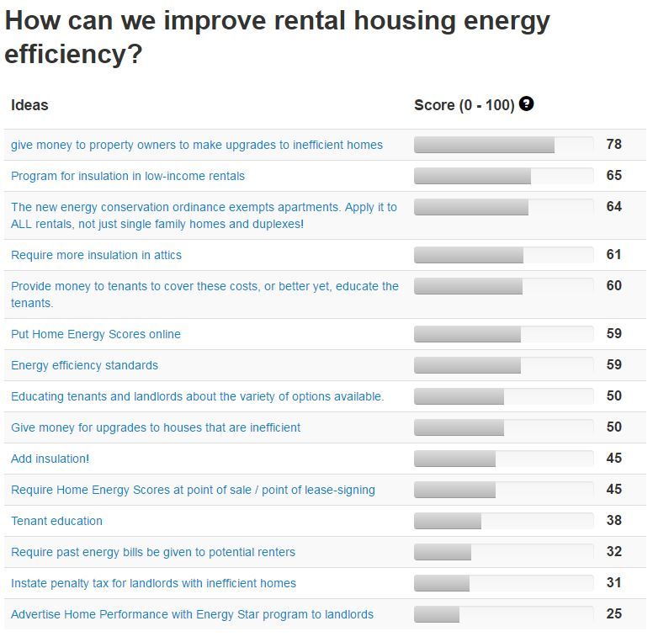
http://www.allourideas.org/comorentalenergy
Ideas, as of February 10, 2017

Appendix B - Rental Property Scoring

The graphs on the next page shows Home Energy Scores and Efficiency Scores for both the final and initial assessment for rental houses participating in the Home Performance with Energy Star program (HPwES). Information gathered when assessed for the HPwES is the data used for calculating the two scores.

CWL provided EEC with data for all houses that had gone through the program through 12/8/2016. 7,170 houses have been through the HPwES program since it started. Of those, 1,263 are identified as being rental property. Only 231 rental units have final scores for both Home Energy Score and Efficiency Score.

Ninety-four percent of rental units would have passed the recommended efficiency standard even though they had no target goal. The 6% who did not reach the goal were very close. Most (66%) would have met the requirement without any improvements but their final scores improved significantly. Obviously, only those property owners with interest in the program participated. We do not know if owners of less efficient units were more or less likely to participate.

Initial and Final assessment scores for rental housing participating in HPwES:

*Standard is a Home Energy Score ≥ 7 or an Efficiency Score of ≥ 70%.

Programs

Home Performance with Energy Star
A trained energy efficiency assessor evaluates the house and makes recommendations for energy efficiency improvements based on the evaluation. If improvements are made, the assessor reevaluates the house and submits rebate requests to Columbia Water & Light and Ameren Missouri.

Home Energy Score
Home Energy Score is intended to provide information for houses similar to MPG ratings for cars. It provides a cost estimate of energy needed to operate the house without occupant behavior having any influence. Scores go from 1, poor, to 10, excellent.

Efficiency Score
Smaller cars on average getter better MPG than larger ones, and its the same with houses; smaller houses use less energy than larger ones. The Efficiency Score measures the house against what it reasonably could obtain, permitting larger houses to report their efficiency. Values go from 0% to 100%, best possible score.

The scores are not influenced by occupant behavior.

Appendix C - List of Benefits from the Proposal

Benefits to Renters
The proposed ordinance provides a way for potential renters to evaluate the total cost of renting by providing renters with an accurate estimate of the total cost of rental housing; rent plus utilities.

Benefits Community
Economy: Jobs that support families - How do we create more living wage jobs?
Increasing energy efficiency in rental housing is accomplished with: insulation; air tightness; HVAC; Lighting; Appliances, all of which require skilled labor to complete.

Social Equity: Improving the odds for success - How can we strengthen our community so all individuals thrive?
The lack of energy efficiency in rental housing has the greatest negative effect on lower income households. The Office of Neighborhood Services says that 57% of rental households are housing cost-burdened. The proposed ordinance partially addresses this by requiring minimal levels of energy efficiency, reducing utility costs.

Infrastructure: Connecting the community - How can we build the future today?
Reducing the electrical load reduces future costs of electric distribution infrastructure thus reducing future cost for all customers.

Benefits the Environment
The Vision for Columbia's Future (October 2007) includes:
Environment:
Vision Statement: Columbia residents and businesses conserve all the community's natural resources, work cooperatively to apply best planning practices, model energy efficiency, transition to renewable energy, and approach zero waste generation.
Goals
Environmental Quality: Columbia and its neighboring communities will be a place where the air, water, land, and natural aesthetic qualities of our environment shall be protected by a combination of conservation strategies including, but not limited to, regulations and ordinances, conservation incentives, education programs, and smart growth planning.
Resource Conservation: Columbia will be a model community that approaches zero waste of all primary and secondary forms of energy and goods, and that implements best management practices in order to protect and conserve its natural resources and intrinsic beauty for future generations.
Energy Efficiency: Columbia will work toward achieving maximum energy efficiency and transition to renewable energy sources.

Appendix D – Comments from Strategic Plan Neighborhood surveys related to home energy

Results have been updated as of 01/10/2017
**1 household did not list their housing status
**4 households stated they were homeless
Central Neighborhood Strategic Planning Survey Comments
- Can't afford utilities right now
- Kids help pay utilities
- Struggles to pay rent sometimes
- struggles to pay rent and utilities (unemployed)
- On low income struggles to pay rent and utilities
- Struggles to pay rent and utilities sometimes
- Difficult to afford utilities in winter
- Difficult to afford utilities
- Need help paying utilities occasionally
- can't afford utilities- looking for steady work (has disability with hand)
- Can't afford utilities- has to choose to pay for diapers or have utilities turned off
- Moved from old units and CHA was supposed to pay for new service connect (Have City look into this for tenants relocating from Unity)
- Struggles with rent and utilities sometimes
- Can afford utilities sometimes
- Can't afford utilities because have to pay rent
- Struggles to pay rent and utilities
- Struggles to pay rent and utilities
- Skips food money to pay rent- CMCA pays utilities
- We need lower rates on utilities
- Behind on utilities: $487 Current bill: $343
North Neighborhood Strategic Planning Survey Comments
- Can only barely afford utilities
- Struggles to afford utilities
- Struggles to pay rent and utilities every month
- Light bill gets high
- Sometimes needs help on utilities
- Hard to afford utilities
- Receives help from CMCA to pay utilities
- Can't afford utilities all the time
- Can't always afford utilities
- Struggles sometimes to afford utilities
- Can afford utilities sometimes
- But need help with water bill. $100 or more
- Needs help with utilities in winter
- Can only afford utilities sometimes- need to lower the light and gas bill
- Electric is high
- Can't afford utilities- Our utilities run $100
- Utilities get high
- Sometimes need help to afford utilities
- Struggles to afford utilities sometimes
- Struggles to afford utilities- insulation is poor
- Needs assistance to afford utilities: mother and daughter are disabled
- Can't afford utilities even though they try to conserve

Data from the City of Columbia’s rental system as of 17 January 2017.
U.S. Census Bureau. American Community Survey Selected Housing Characteristics, 2010-2014 American Community Survey 5-Year Estimates. http://factfinder.census.gov/

